White Noise 2" Set Visit: Hanging With Nathan Fillion, PLUS The First "White Noise 2" Set Photos!
RT-News writes: "Our "White Noise 2" set coverage wraps up with not one, but many delights: a sit down with Nathan Fillion, plus the first ever photos from the spooky set to grace the internet!
If you know Sci-Fi, you know Nathan Fillion. The erstwhile space cowboy Malcolm Reynolds, Fillion rose to idol status in the realm of Sci-Fi/Fantasy geekdom last year with the triumphant big screen bow of the "Firefly" crew in "Serenity," and recently grossed out gleeful gore-hounds in the critically acclaimed "Slither." Now Fillion stars in "White Noise 2: The Light," which is sure to make audiences think twice about dismissing the EVP/supernatural sequel. RT's Senh Duong and Phu Bui-Quang sat down with the dashing jokester between scenes on the Vancouver set of "White Noise 2" to learn more about his character, his upcoming rom-com, and what he expects from his fans.
Rotten Tomatoes: The first "White Noise" dealt with Electronic Voice Phenomenon. In "White Noise 2: The Light," you kind of become the medium.
Nathan Fillion: In the first one, Michael Keaton was listening to TV's and radios to hear messages from his deceased wife. In this one, I have become a de-tuned receiver...I'll just be walking down a street and I'll see something happening that grants me the ability to see in a crowd of people and tell which one is gonna die. And the movie becomes about if you had this ability, what would you do? What could you do?
RT: Can you give us any background about your character in the movie?
NF: He's a normal, everyday, average guy. I've played some characters in the past that have experienced loss; Malcolm Reynolds took loss not very well, but it kind of turned him hard, into a rock. [In "White Noise 2"] Abe -- Abraham Dale is his name -- doesn't take his loss as well. He's on this path of destruction. It destroys him and pulls him apart in a way; he's far more fragile. And then confronted with this ability, what would you do if someone was gonna die?
He's an ordinary guy with extraordinary circumstances. This is what I think all movies are about, ordinary people in extraordinary circumstances.
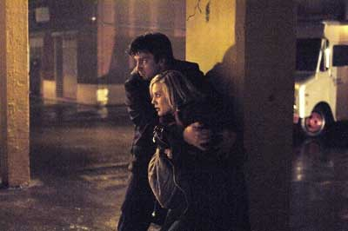
Nathan Fillion and Katee Sackhoff evade the supernatural in "White Noise 2: The Light"
RT: So he's faced with his ability to use his power for good?
NF: Or awesome. Good or awesome, those are his choices.
RT: How is it working with Katee [Sackhoff] in the film?
NF: She's awesome. I think there are people who are cut out to play certain roles and Katee's character, this kind of bubbly, gleeful, certainly not shy nurse, she's just all out there for you. Her interest is in enjoying life. Katee fits the bill. Perfect. Typecast her right there. She's exactly like that, she's not even working that hard.
RT: Since both of you come from sci-fi backgrounds -- you were in "Firefly," and she plays Starbuck on "Battlestar Galactica," -- do you guys ever compare notes, like who would win between your characters?
NF: We trade trading cards. I'll give you a Jane for two Number 6's. That kind of stuff.
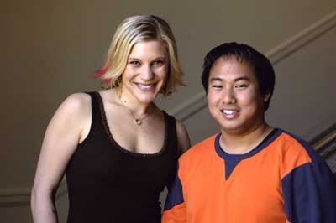
Katee Sackhoff and RT's Phu Bui-Quang, on the "White Noise 2" set
RT: You've worked on a soap opera, as well as a sci-fi series, and a horror film ("Slither," and now "White Noise 2")...one of our readers pointed out that it looks like you're tending toward genres with specific target audiences in mind, as opposed to more mainstream roles, such as a romantic comedy.
NF: I can completely see how it would look that way, but the fact is I don't sit down with five scripts in front of me and say, "you know what, I'm gonna do this one because of the audience it's reaching or I'm gonna do this one because of the genre." I go out for jobs, or jobs come my way, and I want to be a working actor; I want to do jobs that excite me and challenge me, and I want to something fun.
The process is I'll try out for 30 jobs, maybe five of them will call me back to try out again, maybe one of them will hit, maybe, maybe not. Then you've gotta wait for the next 30, you know what I mean. It's a game of numbers, and I'm just plucking along. What I get is what I get.
"Firefly" was a lucky get, I'm really glad that that happened. "Serenity" happened because of "Firefly." It wasn't a choice I made; I was just able to have the opportunity. I did "Slither," I was very, very excited about that (horror genre). It was new, fun and exciting. It was funny. "White Noise 2" was a little bit different; it came along because of "Slither." It's not the choices that I'm making -- it's just the opportunities that are opening up for me.
I'm hoping I get more different opportunities. And I actually do have a romantic comedy coming up call "Waitress." So tell you reader to put that in his pipe and smoke it.
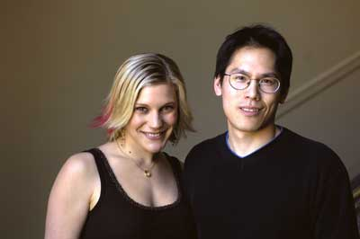
The beautiful Katee Sackhoff delights RT's Senh Duong with a photo op
RT: In a lot of your previous projects you had a comedic role ("Firefly," for instance). "White Noise 2" seems like more of a serious role. How does that change your approach to the character?
NF: You know, my job changes very little because I've found that the more you try to be funny, the less funny you become. When I watch TV I can tell when someone is punching the joke and telling me when to laugh (I'll decide when to laugh, thank you very much), or I can tell when someone is just being in a situation or being under some circumstances that make me laugh, like I'm glad that that's not me. I think that the secret to comedy is not playing the comedy, but actually playing the situation, playing the drama of it.
So playing the drama of a drama is no stretch. What I did love is that they actually put in something very funny in "White Noise 2." I can't even tell you what it is.
I can tell you that they put in a little nod to "Firefly." That was really nice to do, but it might get cut out. They didn't film any options, so almost the whole scene is out, which I don't think it will be. There's a little nod in there to "Firefly," which I'm really happy about, it really honors me.
There's that stuff coming up. That's my niche. Six foot tall and funny, can make you laugh. My manager always likes to say that, "you can do the drama and you can do the comedy." I've found my niche.
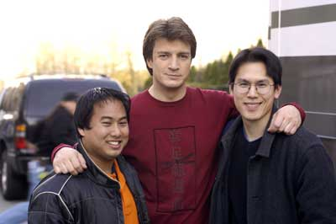
RT's Phu Bui-Quang and Senh Duong make a Nathan Fillion sandwich
RT: So do you think a lot of fans of "Serenity" and "Slither" will like you in this role?
NF: I'm counting on it. I am counting on every "Serenity" fan, and every "Firefly" fan, and every "Buffy" fan, and every "Slither" fan, I am counting on them to see this movie. If this movie fails it is their fault. I'm glad you let me get that clear. I finally had a voice.
RT: We've been reading through the forums and a lot of people weren't too fond of the first "White Noise," but they saw that you were in the cast of "White Noise 2" and have decided to watch it because of you.
NF: This movie is not about the first movie. They've taken it a step further. It's gone beyond; they're not recycling a story or an idea, they're taking it somewhere else. But it shares a theme, certainly, what with 'white noise' in the title.
RT: Did you watch the first "White Noise?"
NF: Yes, I did. I watched the first "White Noise" actually while I was shooting "Slither." And in the hotel I was staying in I was lying in bed watching it, and every time I moved I would catch my reflection moving in the mirrored doors that looked like glass -- it looked like a French door but it was a mirror, so I would see something moving and it would just give me such a start. Those conventions that work to build our tension and to release it, to scare you in movies, that stuff works on me.
"Jaws" changed my life. I will not go near the ocean, I have to be between the shore, me, whoever else is swimming with me has to be on the outside. I'm always on the inside. My diving instructor said, "Nathan, if you ever are with somebody and you see a shark, all you do is you take your dive knife out, and you stab your dive buddy."
I've always kept that with me."

