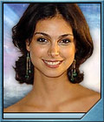
When Morena was 10, she moved with her family to Greenwich Village, New York. She later attended the Fiorello H. LaGuardia High School of Music & Art and Performing Arts (the Fame high school) before she entered the theater program at Juilliard, where Wes Bentley was a classmate.
Morena landed her first movie role in the improvised fashion world comedy Perfume (2001). This was followed by a lead role in the film festival hit Way Off Broadway (2001). Shortly before moving to Los Angeles, Morena appeared with Natalie Portman and understudied for her role in the acclaimed Central Park production of The Seagull. Firefly was her first television show. Morena will reprise her role from Firefly in the film Serenity later. She just got the role of Adria in the upcoming season (10) of Stargate SG-1.
Beware of minor spoilers.
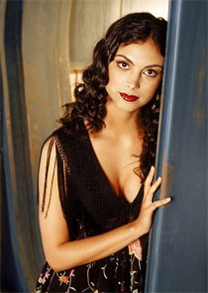
Gilles Nuytens: Thank you very much for this interview, can you firstly speak about yourself?
Morena Baccarin: I don't know what to say... I am looking forward to returning to Vancouver for the rest of my Stargate shoot. I love Canada.
Gilles Nuytens: How aware were you of Stargate before the audition for the role of Adria?
Morena Baccarin: I had heard of Stargate the movie, and heard of both Stargate series. But never had watched them so when they offered me the part I had to do a little bit of homework.
Gilles Nuytens: Did you already shoot some episodes? If yes, can you speak about it?
Morena Baccarin: I've shot one episode, leaving to shoot two more next week. I love the character she is truly evil. The worst kinds of people are the ones with no acceptance and she is one of those. What she believes is the word of God. And I get to wear really cool contacts!
Gilles Nuytens: And what kind of relationship does she have with her mother, Vala?
Morena Baccarin: A loving one in Adria's book. But in my world very twisted.
Gilles Nuytens: You play now in 2 hit sci-fi shows (Firefly, Stargate), what do you think of the sci-fi genre?
Morena Baccarin: I think it's interesting and very creative. A lot of imagination and intelligence usually goes into creating these worlds and I love being a part of it.
Gilles Nuytens: How different was it to play on a movie based on a TV show than on the TV show itself?
Morena Baccarin: The movie was a bigger, better more annexed version of the show. And we were all eternally grateful for being back together.
Gilles Nuytens: What did you enjoy the most on this role (Adria)?
Morena Baccarin: I like the nuances of evil. I am trying to be likeable as well. It's an interesting combination.
Gilles Nuytens: For how many episodes did you sign?
Morena Baccarin: Three. But I think I am doing four, so far.
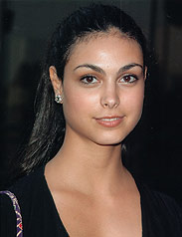
Gilles Nuytens: Do you have a funny anecdote you'd like to share about your time on the sets of Stargate.
Morena Baccarin: Not yet, though it was pretty comical watching me get around feeling the walls with my contact lenses on.
Gilles Nuytens: What would be the role of your dream?
Morena Baccarin: I love Shakespeare, and I have been obsessed with Juliet for a few years. Cleopatra also.
Gilles Nuytens: You character being some kind of a religious leader, how would you compare the religious themes in Stargate with the actual situation in the world?
Morena Baccarin: As with most religions wars start when people cannot see any other way but their own and are not tolerant of other points of view.
Gilles Nuytens: What is your best memory from Firefly?
Morena Baccarin: The whole thing.

