Darko director's follow-up falters
By Darren Waters
BBC News entertainment reporter in Cannes
Donnie Darko director Richard Kelly says his latest film Southland Tales is a work of "political pop art" - but it has received a mixed reception at Cannes.
On being told that people had walked out of his movie during a press screening, the director said he hoped Southland Tales would "push people's buttons".
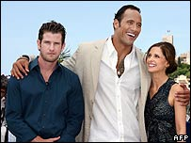
Richard Kelly (left) directed The Rock and Sarah Michelle Gellar
"I look forward to all the discussion about the film," he said.
Southland Tales imagines the impact a terrorist nuclear attack could have on the United States.
"The film is meant to be a tapestry of ideas all related to some of the biggest issues that we are facing right now -whether it is homeland security or alternative fuel or our increasing obsession with celebrity," he said.
Often surreal and mixing many different film styles, the movie is in competition for the prestigious Palme d'Or.
It stars Sarah Michelle Gellar and The Rock, who were both in Cannes with Kelly to support the movie.
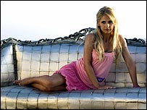
Sarah Michelle Gellar plays a porn star in the film
Gellar, who plays a porn star in the film, said she was concerned that some of the predictions made in the film were beginning to come true.
"We thought it was the most ridiculous idea - a porn star who has a drink line and has a talk show and reality show," she said.
"I have watched specifically America change to this crazy height of celebrity. What seemed ridiculous to us three years ago has slowly evolved into something real."
Early reaction to the film has been decidedly mixed, with some critics damning Kelly's follow-up to the enormously successful Donnie Darko.
Kelly said he wanted the film to be confrontational and aggressive, using a lot of gallows humour.
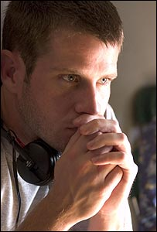
It's pop art but political - it's aggressive and confrontational and we need more art like that
Richard Kelly
"I tried to use humour to talk about some very serious issues we are facing as a country and a planet," he said.
"It's pop art but political. It's aggressive and confrontational and we need more art like that."
Kelly said the film was meant to be viewed like a puzzle.
"This is a film that needs to be experienced in more than one viewing to fully comprehend the intricacies of the puzzle," he added.
The film, like Donnie Darko before it, uses a lot of pop music throughout.
The success of Darko in the UK led to the film's climactic song, a version of Tears for Fears' Mad World, hitting number one at Christmas in 2003.
Pop star Justin Timberlake appears in the film as a crazed Iraq war veteran selling a spiritual drug to people in Los Angeles.
"I think you will see Justin do extraordinary work in the rest of his career as an actor," said Kelly, who said Timberlake's character was the "spiritual centre of the film".
Gellar and Kelly also backed film-making in Los Angeles, where it is set.
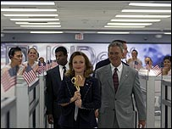
Southland Tales is in the running for the prestigious Palme d'Or
"It is the greatest city on earth," said Kelly.
"It's an under-photographed city. We sacrificed a lot of money to shoot the film in Los Angeles. Someone told us to recreate LA in Canada - nothing against Canada but 'no'."
Gellar added: "In terms of Hollywood, it is supposed to be the epicentre of where we make films. Yet we constantly run our films out of the country and it is depressing.
"I know a lot of people I work with are losing their health insurance and benefits because we constantly recreate every American city in Canada.
"I was really proud to be able to show the LA film-making community how easy it actually it was to shoot in Los Angeles."

